**Report For Prototype_3**



About App

The app has been created with the help of

HTML, JAVASCRIPT, PHP and a SQL database.

In This Prototype We add a method to cache our weather data and add a way to show data of whichever city you want in the world just by typing it in the search box.

***Pros:***

* **Internet Reliability:** If a user recently accessed the app the app will function without use of the internet.
* **Cache:** This is a big change that we have brought upon the app which saves a company or an establishment thousands of pounds, since we have a way to cache the weather data, the user on refreshing the page doesn’t use up the server resources and instead uses stored cache data.

This makes a huge difference as its quite expensive to run a server and every time a user refreshes a page it uses up server resources which we have countered in this prototype.

* **Speed:** The speed of accessing local data is much faster than fetching directly from the API. In prototype 2 it took 82ms to fetch data meanwhile in Prototype 3 it takes a mere 1-5ms to fetch data.

***Cons:***

* **Non-Supporting Browsers:** Local storage uses an API that may not be available in older versions of browsers or HTML
* **Cached Data:** Our Cached Data is stored on our respective devices which means it takes up device storage, minimal storage but it still occupies space.
* **Server-reliability:** Our app still heavily relies on the mi-linux server which means that if the server fails or it is overloaded, our app fails to work.

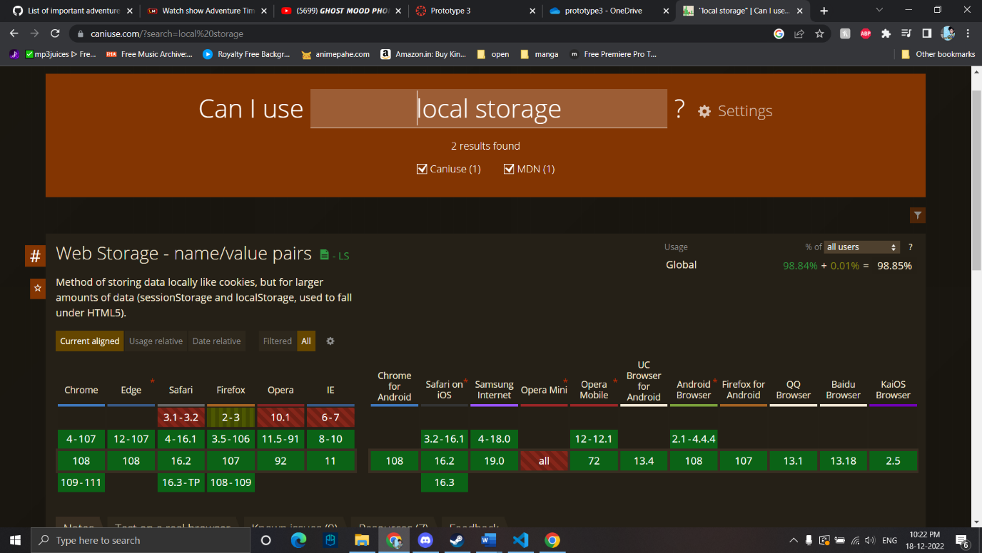

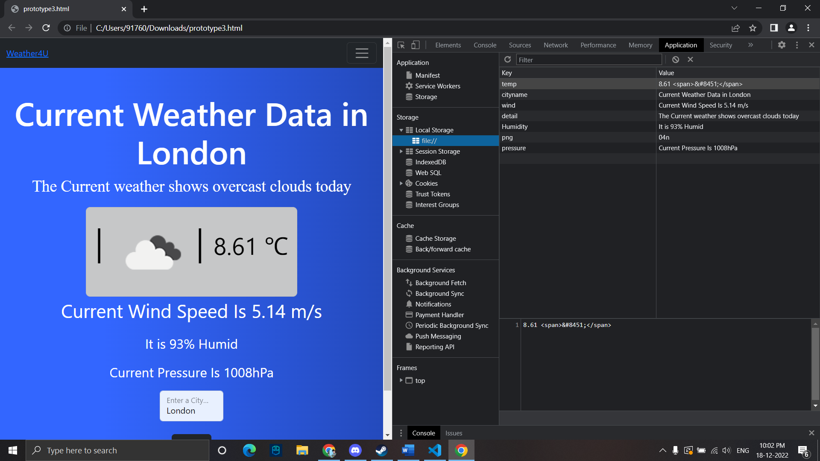

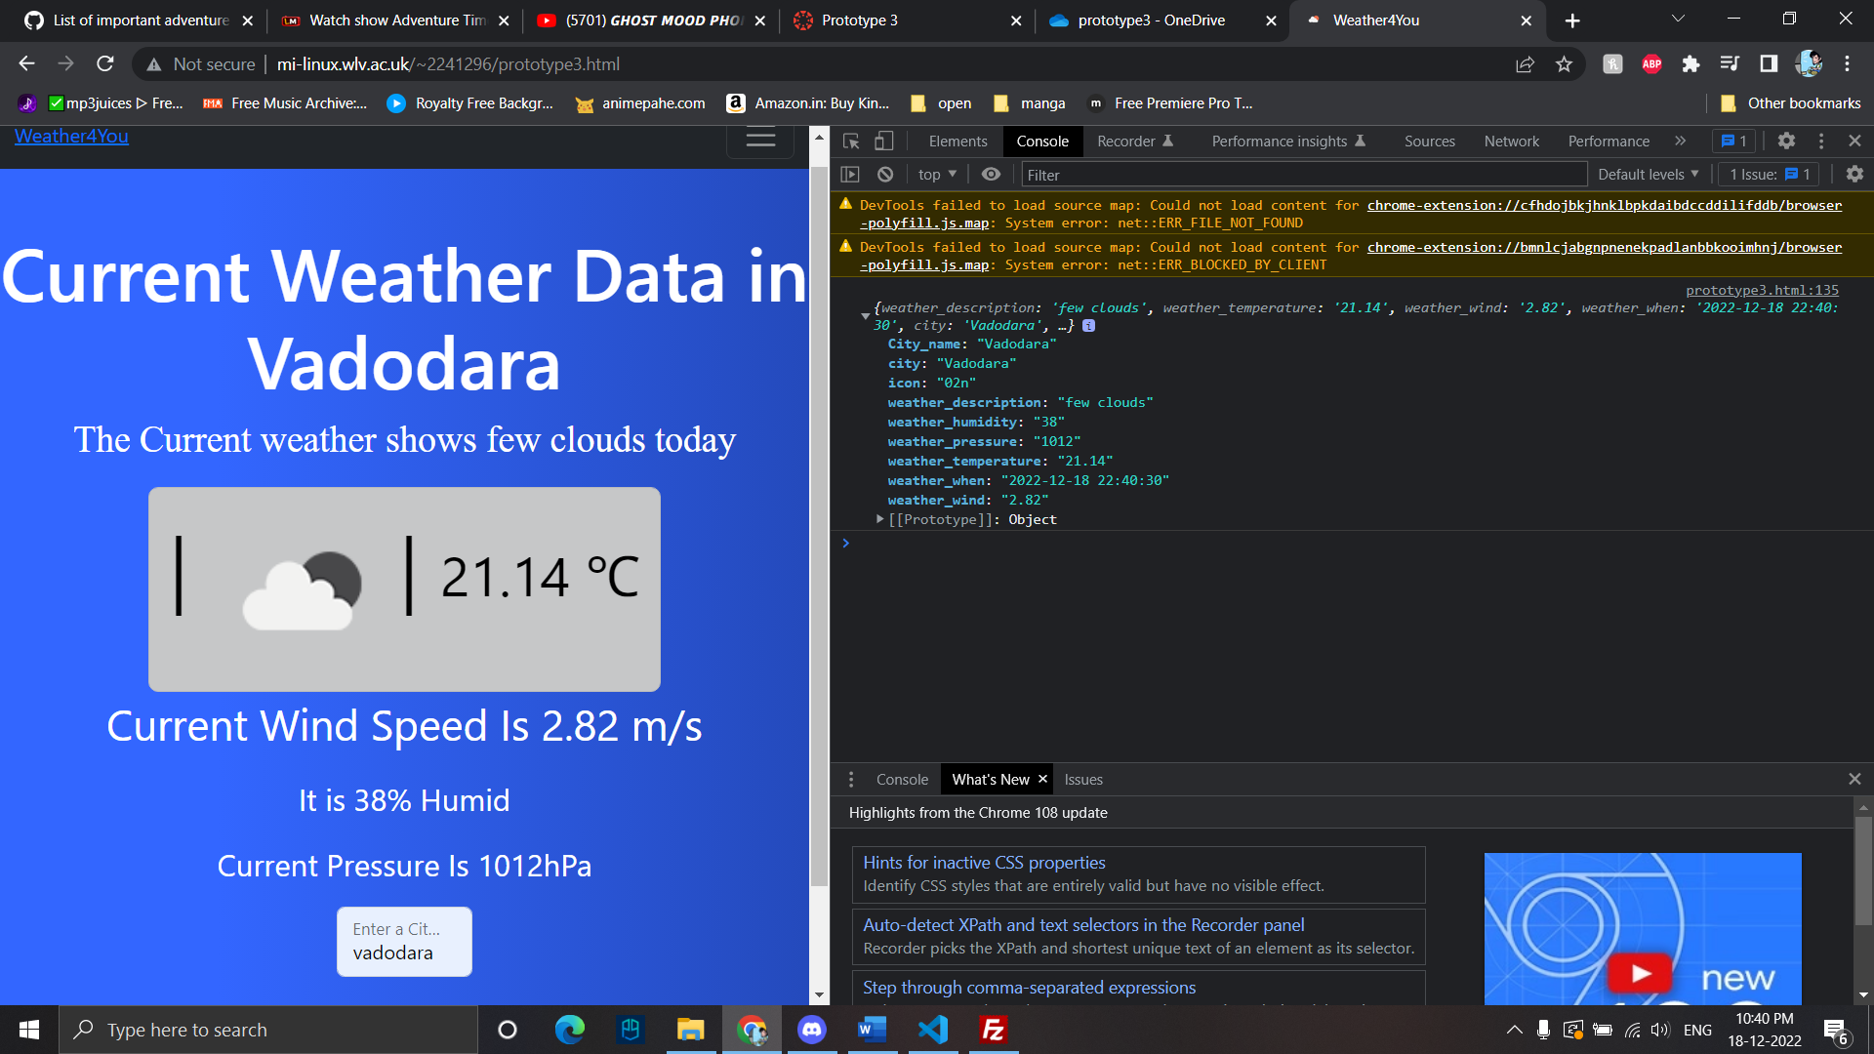

**Link For Prototype3:**

http://mi-linux.wlv.ac.uk/~2241296/prototype3.html

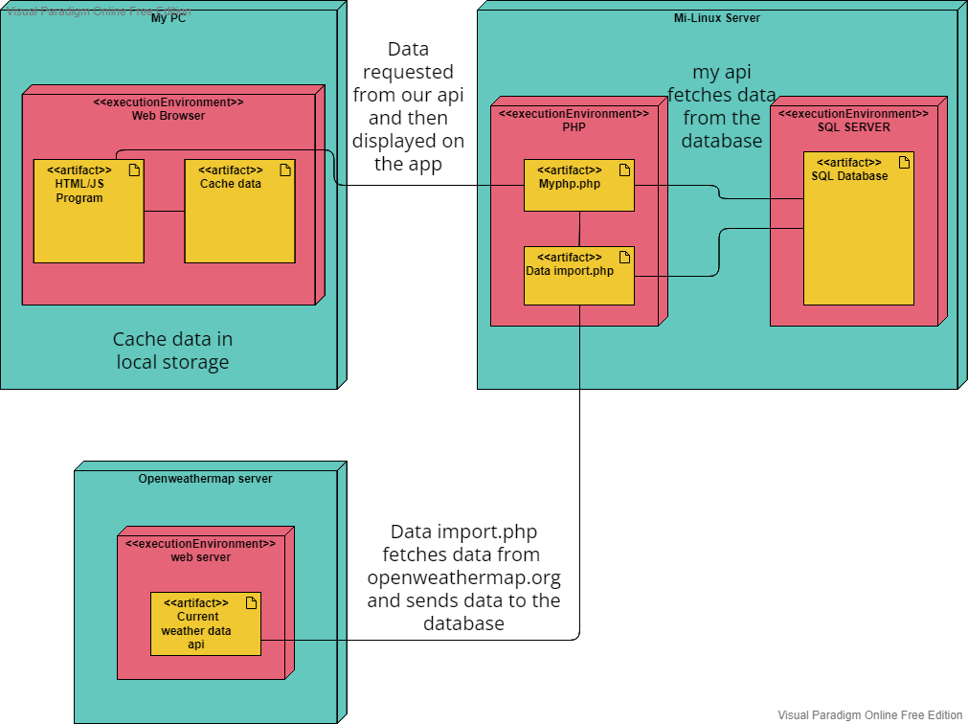**UML Diagram:**